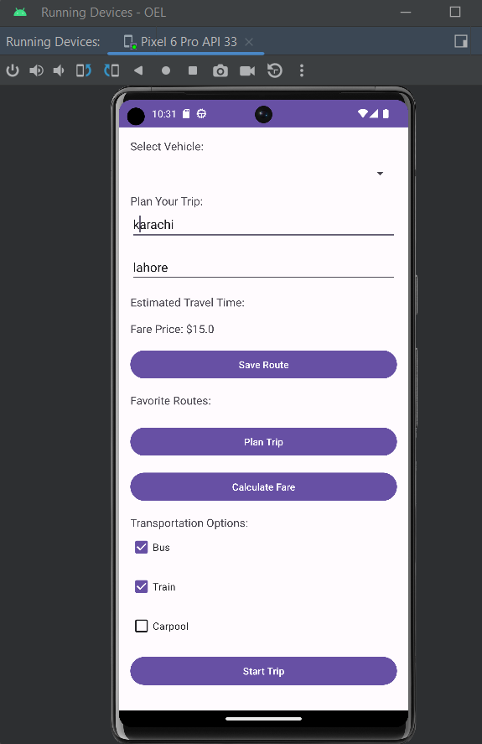

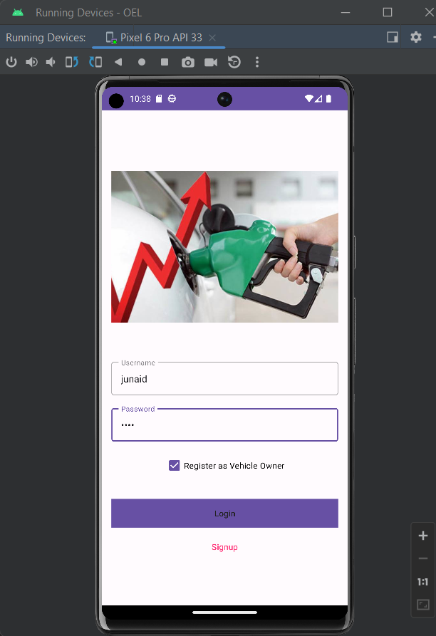

Github = https://github.com/junaidsaleem10144/oel

https://github.com/junaidsaleem10144/oel